Description: Fast

NAT NATIONAL UNIVERSITY OF COMPUTER AND EMERGING SCIENCES

(KARACHI CAMPUS)

Department of Computer Science

**FALL 2019**

**MICRO ECONOMICS**

**PRESENTATION REPORT**

**WALL STREET**

**TEAM MEMBERS:**

* MUHAMMAD UMAIR KHAN ( 18k-1292 )
* MUHAMMAD MUJTABA ( 18I-0623 )
* YUSHA FARID (18k-1289)
* MUHAMMAD AHMED ( 18k-0256 )

**BATCH:** 2018.

**SECTION**: GR-1.

**COURSE INSTRUCTOR:** SIR MICHEAL HIMEN.

Description: Fast

NAT NATIONAL UNIVERSITY OF COMPUTER AND EMERGING SCIENCES

(KARACHI CAMPUS)

Department of Computer Science

**FALL 2019**

**What is Wall Street?**

There are two ways to look at what Wall Street is. It is both a geographical location and the financial mecca of the U.S. (and, arguably, of the world). In terms of geography, Wall Street takes up eight blocks in Manhattan, New York. It runs east to west from Broadway to South Street, in the heart of the financial district. Representing the heart of [capitalism](https://corporatefinanceinstitute.com/resources/knowledge/economics/capitalism/), Wall Street is home to the [New York Stock Exchange (NYSE)](https://corporatefinanceinstitute.com/resources/knowledge/trading-investing/stock-market/), numerous banks, other financial institutions, and corporations.

The phrase, “Wall Street,” is sometimes taken as generally representative of [investment banks](https://corporatefinanceinstitute.com/resources/careers/companies/list-of-top-investment-banks/), securities traders, hedge funds, and [portfolio managers](https://corporatefinanceinstitute.com/resources/careers/jobs/what-does-a-portfolio-manager-do/). It refers to both the people and places that govern the world of finance for the country.

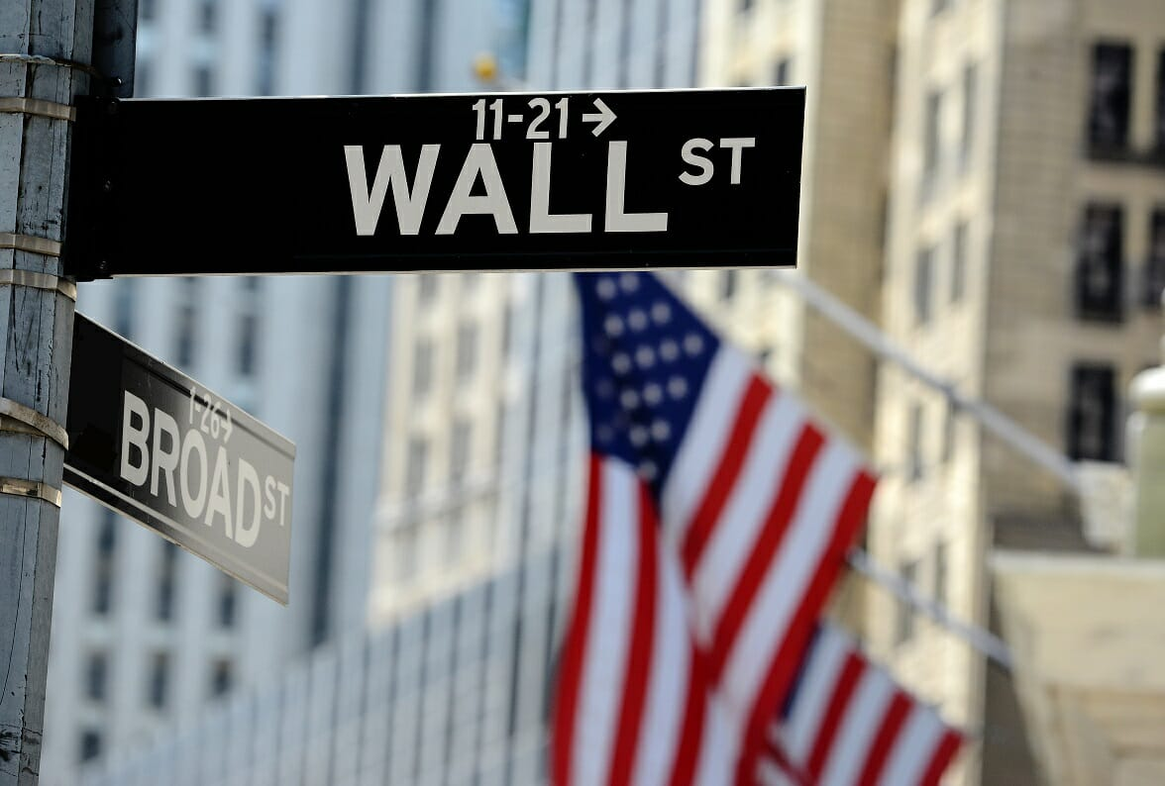

Description: Fast

NAT NATIONAL UNIVERSITY OF COMPUTER AND EMERGING SCIENCES

(KARACHI CAMPUS)

Department of Computer Science

FALL 2019

**Early History of Wall Street:**

Wall Street gets its name from a literal, physical wall built in New York when the town was still a Dutch colony. Governor Peter Stuyvesant called for a 10-foot wall to be built, protecting the lower part of the peninsula from Native Americans.

Later on, the street became known for being a marketplace where traders and buyers met to conduct business. In 1792, the traders and buyers formalized rules to authorize and legitimize their business, leading to the eventual formation of the NYSE.

**Crashes on Wall Street:**

Though not the first economic depression or market crash in the U.S., the Crash of 1929 triggered what quickly became known as the [Great Depression](https://corporatefinanceinstitute.com/resources/knowledge/economics/the-great-depression/). There’s not one specific explanation of what precisely triggered the massive stock sell-off in the fall of 1929. The sharpest stock traders – men such as Jesse Livermore – realized that the stock market had been hugely overbought for quite some time.

Eventually, a small sell-off rolled into a major panic and investors began selling right and left, dropping stock prices and triggering the market as a whole to crash. The Dow Jones lost all its previous gains for 1929 in a matter of hours at the end of October.

The event is important historically when looking at Wall Street for a number of reasons. Many individuals lost faith in the country’s entire economic system. This led to many pulling all their money from banks, subsequently causing the collapse of many financial institutions. The stock market crash and the following depression led to the first major regulation of stock market trading. Close government oversight was instituted by the newly-created [Securities and Exchange Commission](https://corporatefinanceinstitute.com/resources/knowledge/trading-investing/1933-securities-act-truth-securities/). Though many credit Roosevelt’s “New Deal” government spending, it wasn’t until World War II that the U.S. economy really began to recover.

Description: Fast

NAT NATIONAL UNIVERSITY OF COMPUTER AND EMERGING SCIENCES

(KARACHI CAMPUS)

Department of Computer Science

FALL 2019

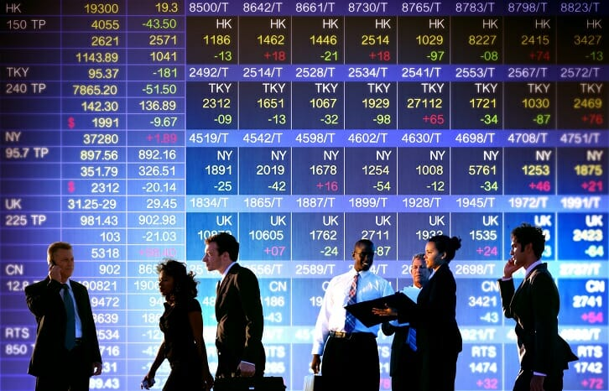

**Housing Market Crash:**

The second most significant – and most recent – market crash came in 2008. The housing market crash was the result of the collapse of hundreds of billions of dollars of [mortgage-backed securities,](https://corporatefinanceinstitute.com/resources/knowledge/trading-investing/mortgage-backed-security-mbs/) traded as credit default swaps. When the underlying mortgages went into default, the defaults piled up to the point that major lenders ran out of financing and started to go under.

The response was quick and devastating: Wall Street traders, lenders, and brokers panicked. Markets around the world started to plummet and banks stopped lending to one another to pick up the slack. Eventually, many banks filed for bankruptcy. It

Description: Fast

NATIONAL UNIVERSITY OF COMPUTER AND EMERGING SCIENCES

(KARACHI CAMPUS)

Department of Computer Science

FALL 2019

is, historically, the greatest economic depression for Wall Street since 1929. It wasn’t until the implementing of the [Troubled Asset Relief Program (TARP)](https://www.federalreserve.gov/supervisionreg/tarpinfo.htm) and the Economic Stimulus Package in 2009 that the financial mecca bounced back. Hefty federal loans bailed out many of the leading financial institutions on Wall Street.

Despite its humble beginnings and numerous ups and downs throughout history, Wall Street is regarded as the world center for capitalism and finance.

### Historic Crashes:

Deregulation was one reason for the [2008 financial crisis](https://www.thebalance.com/2008-financial-crisis-3305679). The derivatives based on mortgages were called [mortgage-backed securities](https://www.thebalance.com/mortgage-backed-securities-types-how-they-work-3305947). They were guaranteed by another Wall Street innovation called [credit default swaps](https://www.thebalance.com/credit-default-swaps-pros-cons-crises-examples-3305920). All of these were traded successfully on the secondary market until housing prices started to fall in 2006. The underlying mortgages started to default, and no one knew how to price the mortgage-backed securities. There were so many defaults that the companies, like AIG, who guaranteed the debt ran out of cash.

Wall Street panicked, global stock markets dropped, and banks stopped lending to each other - creating the worst recession since the Great Depression for Main Street. The only thing that stopped the panic was the federal government bailing out Wall Street with the [TARP program](https://www.thebalance.com/tarp-bailout-program-3305895) in 2008, and restoring confidence with the [Economic Stimulus Package](https://www.thebalance.com/what-was-obama-s-stimulus-package-3305625) in 2009.

This wasn't the first time Wall Street decimated Main Street. The [stock market crash of 1929](https://www.thebalance.com/stock-market-crash-of-1929-causes-effects-and-facts-3305891) kicked off the [Great Depression](https://www.thebalance.com/the-great-depression-of-1929-3306033). It started on October 24, 1929, a day known

Description: Fast

NATIONAL UNIVERSITY OF COMPUTER AND EMERGING SCIENCES

(KARACHI CAMPUS)

Department of Computer Science

FALL 2019

as [Black Thursday](https://www.thebalance.com/black-thursday-1929-what-happened-and-what-caused-it-3305817). It worsened on [Black Tuesday](https://www.thebalance.com/black-tuesday-definition-cause-kickoff-to-depression-3305819) when the Dow lost all the gains of the year in just a few hours. Wall Street bankers had failed in trying to stop plummeting stock prices.

Many [individual investors](https://www.thebalance.com/how-do-individual-investors-buy-stocks-3306180) had put their life savings into the stock market. When they got wiped out, they lost confidence in Wall Street and the American economy. Others withdrew all their savings from banks, which then collapsed. Many people felt that Wall Street was the economy. It was only massive [government spending](https://www.thebalance.com/current-u-s-federal-government-spending-3305763) on the [New Deal](https://www.thebalance.com/fdr-and-the-new-deal-programs-timeline-did-it-work-3305598) and World War II that revived economic growth.

In 2010, Congress passed the [Dodd-Frank Wall Street Reform Act](https://www.thebalance.com/dodd-frank-wall-street-reform-act-3305688) to prevent another financial crisis by giving the federal government more oversight of Wall Street. For example, non-bank financial firms like hedge funds were required to register with the [Securities and Exchange Commission](https://www.thebalance.com/u-s-securities-and-exchange-commission-3305995) and provide information about their trades and total holdings. If any financial firms got [too big to fail](https://www.thebalance.com/too-big-to-fail-3305617), Dodd-Frank's Financial Oversight Committee would recommend they be regulated by the [Federal Reserve](https://www.thebalance.com/the-federal-reserve-system-and-its-function-3306001).

Dodd-Frank required that the riskiest derivatives be regulated by the SEC or the Commodity Futures Trading Commission. It asked the agencies to set up a derivatives clearinghouse, like the stock exchange, to make these transactions more transparent.

Description: Fast

NATIONAL UNIVERSITY OF COMPUTER AND EMERGING SCIENCES

(KARACHI CAMPUS)

Department of Computer Science

FALL 2019

### The Occupy Wall Street Movement:

[Occupy Wall Street](https://www.thebalance.com/hillary-clinton-2016-economic-plan-3305767) was another reaction to the financial crisis. Its "leaderless resistance movement" began on September 17, 2011, with a non-violent occupation of Liberty Square in New York's Financial District. It spread to over 1,500 cities around the world.

Occupy Wall Street opposed [income inequality](https://www.thebalance.com/income-inequality-in-america-3306190), in which 1 percent of the world's population owns 40 percent of its wealth. They blamed Wall Street for creating the financial crisis, recession, and resultant [long-term unemployment](https://www.thebalance.com/long-term-unemployment-what-it-is-causes-and-effects-3305518). They worked to take back the democratic process. They claimed it is controlled by Wall Street's money, connections, and power. Their [Principles of Solidarity](http://www.nycga.net/resources/principles-of-solidarity/) were:

* A transparent participatory democracy.
* Personal and collective responsibility.
* Recognizing individual rights.
* Collective resistance of oppression.
* More value for labor.
* Individual privacy.
* Education as a human right.
* Making technologies, knowledge, and culture open to all.

Since then, the group has splintered into many factions. Its core tenets about income inequality, the 1 percent, and the influence of big money on politics have remained. Income inequality is a core plank in Hillary Clinton's 2016 campaign. Its call for a

Description: Fast

NATIONAL UNIVERSITY OF COMPUTER AND EMERGING SCIENCES

(KARACHI CAMPUS)

Department of Computer Science

FALL 2019

higher national minimum wage was taken up by many cities, states, and corporations. The Occupy movement also influenced lawmakers to look at forgiveness of student debt.

### Wall Street Bull:

The Wall Street bull is a statue that symbolizes Wall Street. A [bull market](https://www.thebalance.com/what-is-a-bull-market-3305821) is when stock prices rise, and is considered more profitable than a [bear market](https://www.thebalance.com/what-is-a-bear-market-difference-from-a-bull-3305814), although savvy Wall Street traders can make money in any market. The Wall Street bull has been moved off of Wall Street to 26 Broadway.

**New York Stock Exchange:**

The **New York Stock Exchange** (**NYSE**, nicknamed "**The Big Board**") is an American [stock exchange](https://en.wikipedia.org/wiki/Stock_exchange) located at 11 [Wall Street](https://en.wikipedia.org/wiki/Wall_Street), [Lower Manhattan](https://en.wikipedia.org/wiki/Lower_Manhattan), [New York City](https://en.wikipedia.org/wiki/New_York_City), [New York](https://en.wikipedia.org/wiki/New_York_(state)). It is by farthe [world's largest stock exchange](https://en.wikipedia.org/wiki/List_of_stock_exchanges) by [market capitalization](https://en.wikipedia.org/wiki/Market_capitalization) of its listed companies at US$30.1 trillion as of February 2018. The average daily trading value was approximately US$169 billion in 2013. The NYSE [trading floor](https://en.wikipedia.org/wiki/Trading_room) is located at 11 [Wall Street](https://en.wikipedia.org/wiki/Wall_Street) and is composed of 21 rooms used for the facilitation of trading. A fifth trading room, located at [30](https://en.wikipedia.org/wiki/30_Broad_Street) [Broad Street](https://en.wikipedia.org/wiki/Broad_Street_(Manhattan)), was closed in February 2007. The main building and the 11 Wall Street building were designated [National Historic Landmarks](https://en.wikipedia.org/wiki/National_Historic_Landmark) in 1978.

Description: Fast NATIONAL UNIVERSITY OF COMPUTER AND EMERGING SCIENCES

(KARACHI CAMPUS)

Department of Computer Science

FALL 2019

#### Importance Of Wall Street In the New York Economy:

Finance professor Charles R. Geisst wrote that the exchange has become "inextricably intertwined into New York's economy". Wall Street pay, in terms of salaries and bonuses and taxes, is an important part of the economy of [New York City](https://en.wikipedia.org/wiki/New_York_City), the [tri-state metropolitan area](https://en.wikipedia.org/wiki/Tri-State_area_(NY-NJ-CT)), and the [United States](https://en.wikipedia.org/wiki/Economy_of_the_United_States). In 2008, after a downturn in the stock market, the decline meant $18 billion less in taxable income, with less money available for "apartments, furniture, cars, clothing and services". A falloff in Wall Street's economy could have "wrenching effects on the local and regional economies".

Estimates vary about the number and quality of financial jobs in the city. One estimate was that Wall Street firms employed close to 200,000 persons in 2008. Another estimate was that in 2007, the financial services industry which had a $70 billion profit became 22 percent of the city's revenue. Another estimate (in 2006) was that the financial services industry makes up 9% of the city's work force and 31% of the tax base. An additional estimate from 2007 by Steve Malanga of the [Manhattan Institute](https://en.wikipedia.org/wiki/Manhattan_Institute) was that the securities industry accounts for 4.7 percent of the jobs in New York City but 20.7 percent of its wages, and he estimated there were 175,000 securities-industries jobs in New York (both Wall Street area and midtown) paying an average of $350,000 annually. Between 1995 and 2005, the sector grew at an annual rate of about 6.6% annually, a respectable rate, but that other financial centers were growing faster. Another estimate, made in 2008, was that Wall Street provided a fourth of all personal income earned in the city, and 10% of New York City's tax revenue. The city's securities industry, enumerating 163,400 jobs in August 2013, continues to form the largest segment of the city's financial sector and an important economic engine, accounting in 2012 for 5 percent of private sector jobs in New York City, 8.5 percent (US$3.8 billion) of the city's tax revenue, and 22 percent of the city's total wages, including an average salary of US$360,700.

Description: Fast NATIONAL UNIVERSITY OF COMPUTER AND EMERGING SCIENCES

(KARACHI CAMPUS)

Department of Computer Science

FALL 2019

**REFERENCES:**

* <https://corporatefinanceinstitute.com/resources/knowledge/finance/wall-street/>
* <https://en.wikipedia.org/wiki/Wall_Street#In_the_New_York_economy>
* <https://www.thebalance.com/wall-street-how-it-works-history-and-crashes-3306252>
* <https://en.wikipedia.org/wiki/New_York_Stock_Exchange>

**THAT’S ALL THANK YOU !**